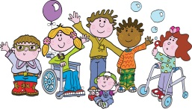

BATTLEDOWN CENTRE FOR CHILDREN & FAMILIES

BEHAVIOUR SUPPORT POLICY

Date of Policy: September 2022

Review Date: September 2023

Signed by _______ _________________________ Date _____
Chair of Governors

Introduction
The Behaviour Support Policy promotes a positive attitude and approach to pupil’s behaviour. The most effective way is by supporting pupils to manage their own behaviour. We aim to provide an environment where pupils enjoy learning, are able to participate in activities and have the opportunities to achieve high standards; following our school ethos of removing barriers and enabling learning. All pupils and staff within school have to right to feel safe, secure and happy.
Staff within the school value every pupil and offer a secure, nurturing and enjoyable learning environment where expectations are high, clear, fair and consistent. School rules are displayed in every classroom.

Aims:
- To promote positive self-esteem
- To keep pupils and staff safe
- To create a purposeful, safe and happy atmosphere where pupils feel confident to develop as individuals
- To encourage independence and a sense of personal responsibility
- To encourage pupils to show kindness, respect and tolerance of each other and the school
- To model and reinforce appropriate behaviour
- To value achievement of all pupils at all levels
- To promote positive working relationships where pupils are able to reflect on the impact and consequences of their actions
- For the school community to work towards the school’s values and ethos (Appendix 3)

Purposes:
Pupils
We expect pupils will:
- Respect other pupils in the way they talk and treat each other
- Show respect for adults
- Respect and look after all property
- Look after one another and show kindness towards each other
- Reflect on their actions and build upon their social skills and interactions.
- To be part of a safe and secure working environment
- Build safe and trusting relationships within the school.
Staff
Staff will be responsible of the behaviour management of pupils within their care and be aware of behaviour plans and appropriate strategies for each pupil. Teachers and Learning Partners will be trained in Team Teach. All staff will have regular behaviour training and refresher Team Teach. Staff will have a sound knowledge of pupils within their care taking into account their needs and triggers. All staff will aim to build positive working relationships with pupils within their class that involve mutual support, respect and trust.
- Staff will ensure they take the time to build trusting & secure working relationships with the pupil.
- Staff will ensure they remain calm in challenging situations and will endeavor to de-escalate situations before they arise by knowing pupils’ interests and calming strategies that work for them this will be done by building successful trusting relationships with pupils within our care.
- Staff will ensure that they use a total communication approach to enable pupils to understand and express need.
- Staff will work with pupils on recognising and expressing emotions in a safe way throughout the school day e.g. circle time.
- Staff will ensure that any pupil who needs a Behaviour Plan has one so that all staff are aware of a pupil’s triggers, needs and de-escalation approach to be used.
- When working with pupils who are in a heightened state of arousal staff will ensure that they are using clear concise language and visuals giving the pupil time to process.
- Team teach may be used to help a pupil de-escalate and keep the pupil, peers and staff safe. (N.B. Staff will be trained in Team Teach Techniques)

We expect staff will:
- Understand that behaviour is part of a pupil’s communication system
- Be positive role models for all pupils.
- Explore our emotions and role model the safe expression of these emotions
- Co-regulate emotions and behaviours with the pupils to support learning within this area
- Provide pupils with clear expectations of behaviour which supports the whole school policy and ethos.
- Positively reinforce & recognise examples of good behaviour, for example using stickers, certificate, verbal praise and other rewards as appropriate. Classes use differentiated approaches to reward positive behaviour, this may be a whole class approach or vary according to individual pupils.
- Keep clear records of positive and negative behaviour as appropriate, including triggers, successful and unsuccessful strategies. This will be recorded on CPOMS and Weekly Behaviour Record.
- Work collaboratively to understand behaviour with staff teams, behaviour leads, parents and SLT.
- Weekly discussions during Teacher meeting to share positive and challenges regarding behaviour’s within classes. Staff will have the opportunity to discuss behaviours and concerns as a wider team, sharing ideas, strategies and support. Staff will name pupils and as a team we will look at solutions and suggestions to move forward. SLT/Behaviour leads will arrange more in-depth meetings with classes as needed to focus and support individual pupils. An individual Behaviour Plan will be implemented if necessary (Appendix 5).
- Keep parents fully informed about issues concerning behaviour either through Class Dojo, telephone or meeting depending on the circumstances.
- Ensure the LAB are regularly updated on the school’s behavior approach and incidents through the termly report.

Parents/Carers
We expect Parents/Carers will:
- Be involved and support all aspects of their child’s behaviour in school including individual behaviour plans (if appropriate)
- Keep school informed about their child’s behaviour at home
- Be involved in support us to meet the aims of this behaviour policy

Governers
We expect Governors will:
- Know that staff are constantly striving to provide a safe secure and happy environment for all pupils
- Be informed of matters concerning behaviour and positive handling incidents
- Support the Head Teacher and staff in the implementation of this policy ethos
- Play an active role in ensuring our aims are met
Behaviour
Whilst we are creating a culture that promotes appropriate behaviour, the pupils at times will display inappropriate behaviour. These include:
- Child-on-child physical abuse
- Child-on-adult physical abuse
- Serious disruption to learning
- Environmental Damage
- Verbal abuse
- Behaviour Online
Behaviour Protocol:
Staff use a variety of behaviour strategies to encourage positive behaviour including the following:

- Reward the positive behaviours
- Understand what motivates individual pupils and use motivators to encourage appropriate behaviour
- Use LP’s to support or work with the relevant pupil
- Use warnings using total communication approach
- Time-out
- Change of face including other classes/behaviour team
- Photo/picture cues
- Distractions
- Humour
- Planned ignoring of inappropriate behaviour
- Use pupil’s Behaviour Plan (Appendix 5)
- Use class/pupil reward system
- Talk to the pupil
- Calm Boxes/Sensory
- We monitor pupils whilst using ICT and educate pupils about appropriate websites
All behaviours are clearly recorded on CPOMS; Battledown’s online behaviour recording system (see Appendix 2) this allows a clear picture of what works for the pupil and builds a picture of patterns of behaviour, this is monitored by SLT and Behaviour Leads.

Rewards:
When giving rewards to pupils we always make clear why we are rewarding the pupil and this will model positive behaviour to other pupils. Effective praise helps the pupils understand the behaviour expected in class and achievement is celebrated. It is important to acknowledge effort, engagement and positive behaviour in order to motivate a pupil. Rewards we give include:
- High fives, smiles, thumbs up
- Private praise
- Public praise where appropriate
- Stickers
- Certificates
- Wow moments
- Informing parents/carers
- Individual reward system
- Positive touch- The use of touch is a vital aspect of our nurturing role and that adult physical contact is not only inevitable but desirable. Touch not only promotes a pupil’s social and emotional development but is also a highly effective and powerful method of non-verbal communication, it is key to the development of healthy relationships and a method of stress relief. It can be used to: show acceptance, provide reassurance, demonstrate affection, calm and provide comfort, emphasise the spoken word, provide sensory stimulation, engage in personal care routines, offer an alternative to spoken communication, remove a pupil from danger or keep a pupil safe. We need to encourage appropriate touch so pupils are able to learn to distinguish between appropriate and inappropriate touch. We want to encourage friendly, nurturing, reassuring and comforting touch. Examples of appropriate touch are:
  - Respecting the personal privacy and personal space of pupils
  - Responses affecting the safety and well-being of the pupil (e.g. holding the hand of a pupil while crossing the street, using a Team Teach hold when a pupil becomes a danger to themselves or others)
  - Responses supporting social and emotional development such as side hugs, lap sitting for younger pupils if initiated by pupil, reassuring touches on the shoulder, back rubs
  - Touch for health and hygiene, personal care
  - Caring hands
  - Deep Pressure Massage to support pupils to regulate

Reflection:
When dealing with negative behaviours we must always be aware that a pupil is trying to communicate with the adult. We must also be aware of the pupils’ self-esteem and that it is the behaviour that is unacceptable never the pupil. We acknowledge the pupils’ feelings and support their understanding and management of their feelings; e.g ‘I can see you are very angry, let’s go outside’ ‘It is ok to feel angry but we cannot hurt our friends’. The first and most important steps are ensuring the pupil has a chance to regulate their emotions, ensuring they and others are safe. Reflection with individual pupils may need to take place once the pupil has regulated their emotions, in some cases, this may be sometime after the incident has occurred.

Once a pupil is calm, staff will reflect on their behaviour with the pupil, if this is appropriate. For pupils who can reflect on their behaviour, we will have a discussion using a total communication approach to establish if they understand why the behavior is unacceptable and the impact the behaviour has on their peers. For some pupils, the use of discussion to reflect on their behaviour is not appropriate. For these pupils, staff will reflect on these incidents using positive visuals e.g. kind hands, emotions (Appendix 6).

Staff will reflect daily on incidents of behaviour and look at strategies to avoid the same situation reoccurring. For examples (see Appendix 4).

Recording
- Some pupils have individual Behaviour Plans. These Behaviour Plans are put on Sharepoint, in the class folder and Behaviour Team folder. They are shared with all involved with the pupil. Parents are involved in writing these plans and sign to agree they are happy with the procedures and information within it.
- Behaviour incidents involving injury to adult, injury to pupil, serious disruption and Team Teach techniques will be recorded on CPOMS
- Weekly Behaviour Records (Appendix 4) will be used to record behaviours, both positive and negatives. These will be checked and monitored by the Behaviour Team and stored in a class behaviour file. This will accurately ascertain the frequency of certain behaviours.
- Pupil’s individual risk assessment will be annually reviewed or following significant incidents within school.

Serious Incidents
- Teachers need to judge the level of danger and act accordingly- danger to pupil, other pupils, staff, equipment.
- Remove the pupil from the situation/ remove situation if necessary
- Call for support from other staff within class/school
- Allow pupil to calm down- support them with co-regulation and or self-regulation.
- Use of safe space as required in agreement with parents and clearly written on behaviour plan.
- At the end of the session, if appropriate speak to the pupil, record on CPOMS.
- Pupil’s parents informed. Parental meetings called when needed to discuss concerns with behaviour and how to move forward.
- Update of risk assessments and Behaviour Plan if needed.
- All serious incident will be reviewed by the Behaviour team and SLT
- Incidents classed as serious are:
  - An injury to a pupil/member of staff that requires first aid
  - Absconding
  - Head injury
  - Extensive damage to property
  - Using equipment as weapons
  - Knives

Positive Handling
Battledown staff are trained in using Team Teach positive handling techniques. The fundamental principle being de-escalation, with positive handling only being used as a last resort and when all de-escalation techniques has not been effective. This should only be necessary if a pupil is in danger of harming themselves/others, damaging property, removing severely disruptive pupils from the classroom where they have refused to follow instructions to do so. Any positive handling should be recorded on CPOMS as promptly as possible, at the end of the school day at the latest and are reviewed by SLT and Behaviour Leads. The pupil’s risk assessment and Behaviour Plan will be updated if necessary and parents will be informed. Following a Team Teach intervention a first aider will check over a pupil to ensure they are safe and injury free. When using Team Teach interventions there will always be 2 adults present, and staff will team teach to a safe area for the pupil. A Behaviour reflection sheet will be completed by staff involved post an incident (see Appendix 6) The Team Teach leads within the SANDMAT will ensure staff are kept up to date with policies and procedures around Team Teach.

Safe Space
The safe space at Battledown is an area within school which provides a safe area for withdrawal or retreat. The guidelines are displayed by the safe space and all staff are aware of these (Appendix 7).

The Safe Space can be used as a de-escalation resource by staff or a withdrawal/retreat which pupils may choose to use when offered by an adult– to calm down in a quieter space until they are ready to re-join the class.

GUIDELINES FOR USE
- The safe space maybe used as part of a de-escalation strategy, this must be detailed in a pupil’s individual Behaviour Plan.
- Whenever a pupil is in the safe space, two members of staff will monitor by direct observation.
- Pupils may be offered and encouraged to use the safe space when they are showing signs which may lead to an emotional outburst. It should be used as a calming, safe area.
- The use of safe space is identified in a pupil’s Behaviour Plan which will be shared and signed by parents.
- All visits to safe spaces are logged stating date, length of stay and name of accompanying staff (Appendix 8)
- In cases of extreme and dangerous behaviour and for the safety of either the pupil or others, the specific safe space can be temporarily secured whilst the pupil remains observed.

Extract from ‘Behaviour & Discipline in School, January 2016, page 12, para 42
42. Schools can adopt a policy which allows disruptive pupils to be placed in an area away from other pupils for a limited period, in what are often referred to as seclusion or isolation rooms. If a school uses seclusion or isolation rooms as a disciplinary penalty this should be made clear in their behaviour policy. As with all other disciplinary penalties, schools must act reasonably in all the circumstances when using such rooms. Any use of isolation that prevents a pupil from leaving a room of their own free will should only be considered in exceptional circumstances. The school must also ensure the health and safety of pupils and any requirements in relation to safeguarding and pupil welfare.

Restriction of Liberty
Under The Children’s Act 2006, any practice or measure such as 'time out' or seclusion, which prevents a child from leaving a room or building of his or her own free will may be deemed a 'restriction of liberty'. Under this Act, restriction of liberty of children by a local authority is only permissible in very specific circumstances.

There may be instances where it is appropriate to restrict a child who may be at risk due to a lack of awareness or danger to a room or a particular area in order to keep him/her safe, e.g. if s/he has a severe learning disability and/or their ability to make safe choices is temporarily impaired by severe anxiety or rage, resulting in challenging and unsafe behaviour. However, it must be ensured that they are cared for under close adult supervision at all times and the incident fully recorded and reported. This must also be reported to a member of SLT as soon as possible.

No school should unnecessarily restrict the liberty of a child.

Exclusions
Exclusions would be a last resort and would happen in consultation with parents, SAND Academies Trust CEO and the LAB.

Review
In order to ensure effectiveness, the behaviour support policy will be monitored and reviewed annually

Appendix 1- Class Reward System

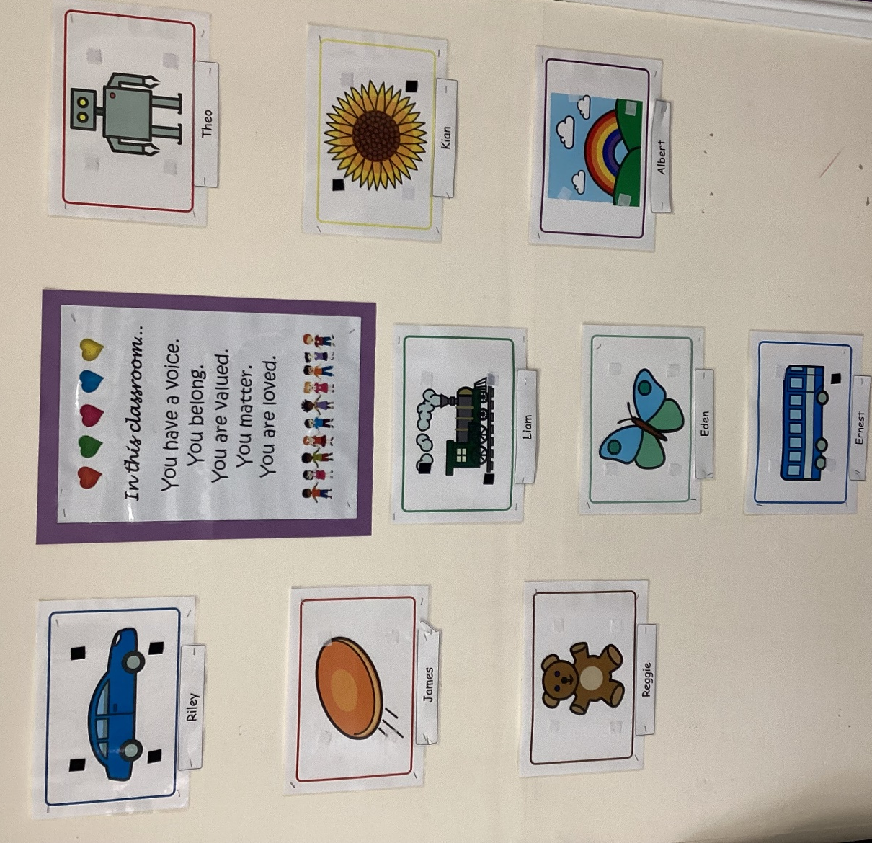

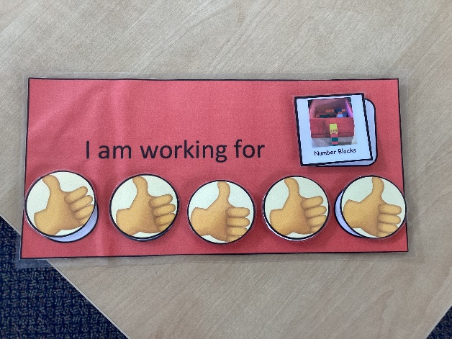

Appendix 2-
Prompt Sheet for Recording Physical Interventions on CPOMS

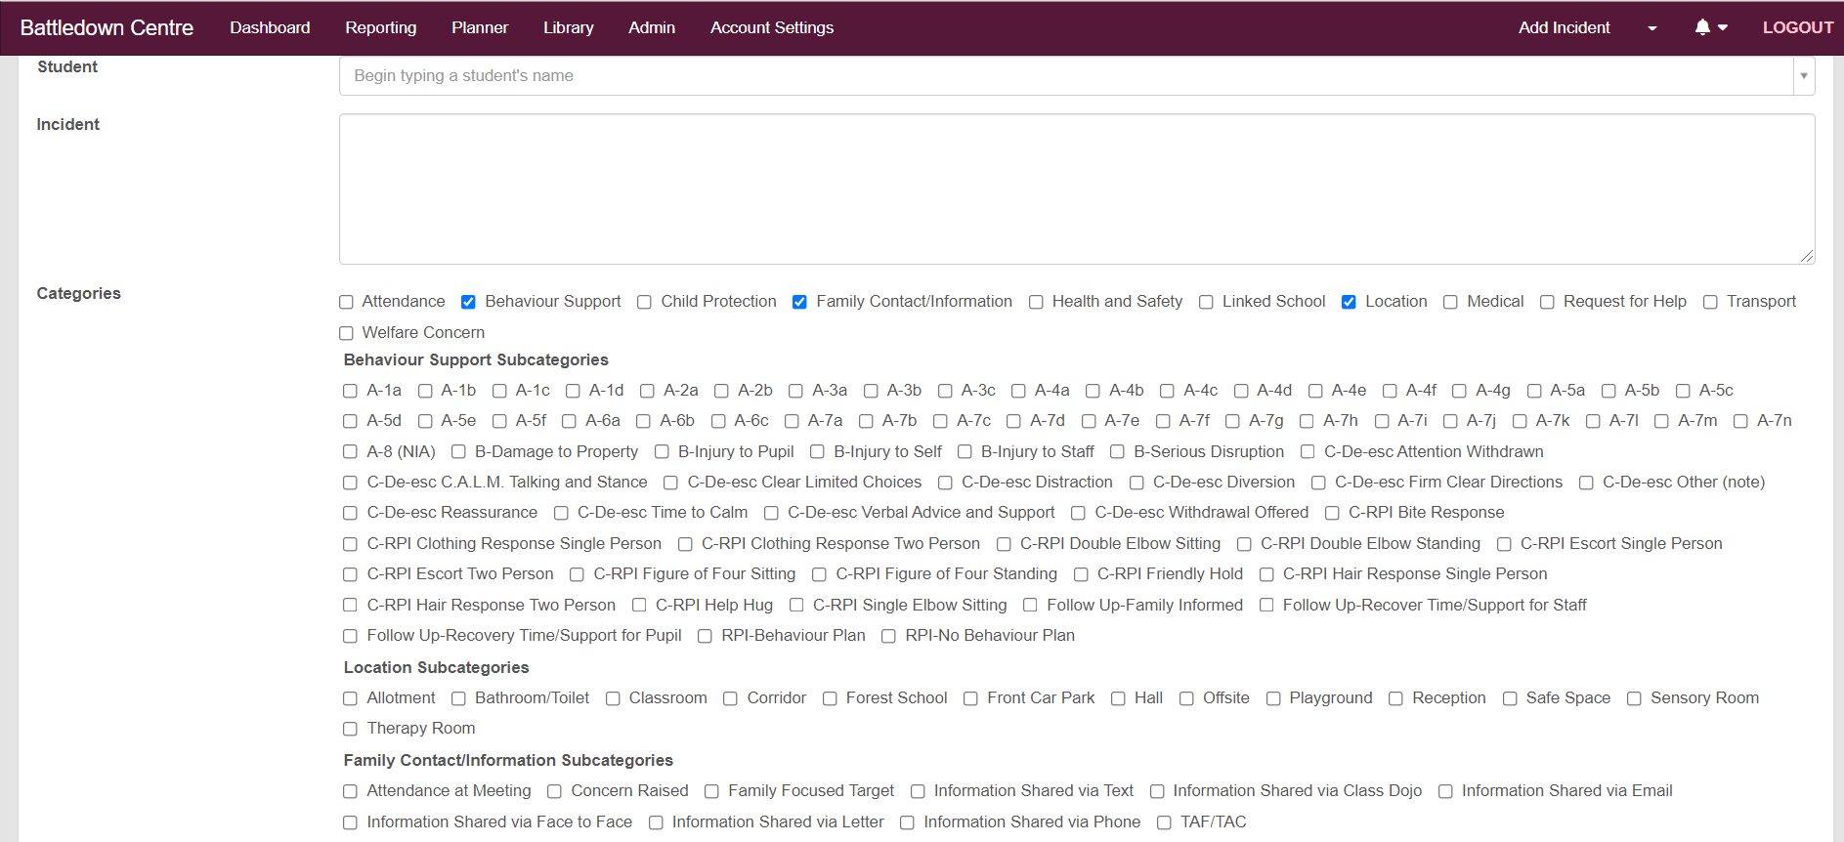
Please Tick ALL these details: (each behaviour requires all this information)
Behaviour Support
- Antecdents: what caused the behaviour?
- Behaviour
- Consequence
- One of these options MUST be ticked- RPI-Behaviour Plan or RPI-NO Behaviour Plan
- Follow up-Family informed. Time support for pupil. Time Support for Staff.
Location
- Tick where it happened

Family Contact/Information
- Parents/Carers MUST be informed of any RPI.
- Please tick how you have let them know.

In the Incident Box please write ALL these details to explain the situation:
Be clear, factual and descriptive.
How did you escort? How did you maneuver?
- The location
- The antecedents- situation the behaviour occurred in. What did you do to prevent the RPI?
- Which hold was used-how you got into it.
- Duration of hold/escort
- Who was involved-please write first names (not initials)
- Post Incident support- How parents informed, follow up, first aid, recovery time.

Restrictive Physical Interview (RPI)

Appendix 3- School Rules

To be followed by every class throughout the school

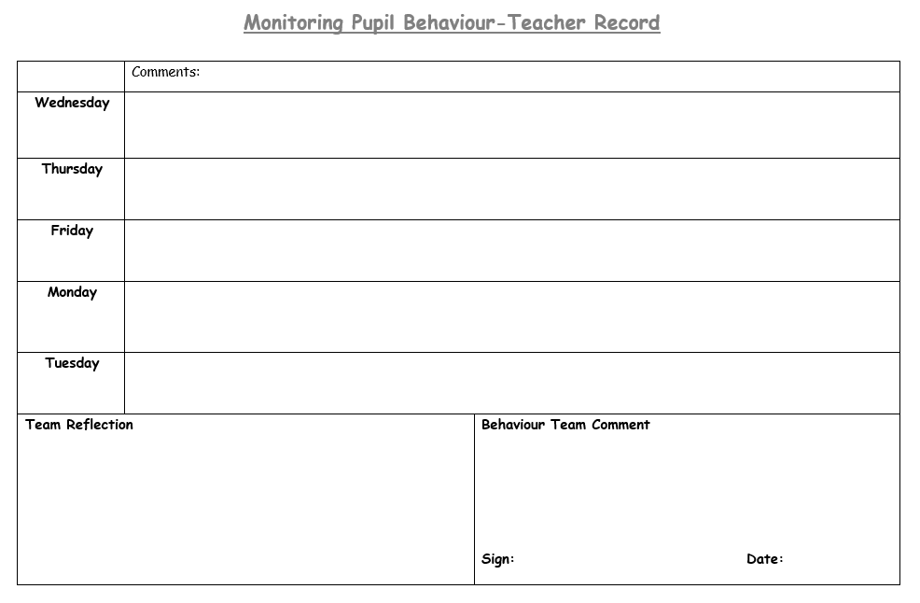
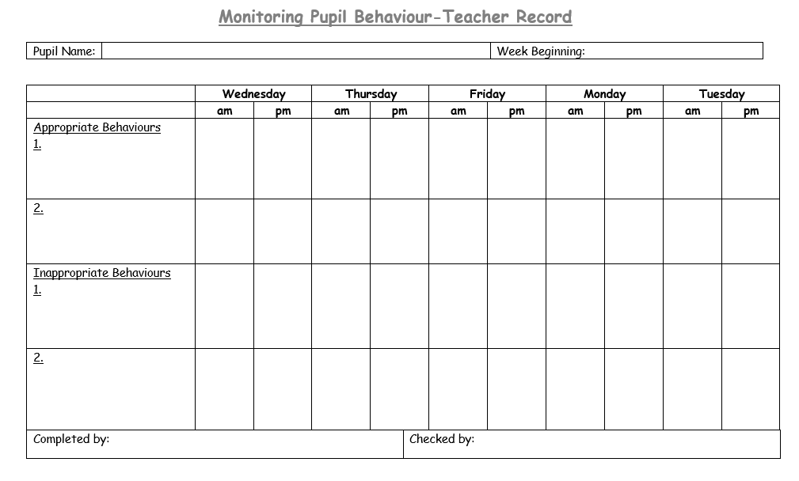
Appendix 4- Monitoring Pupil Behaviour Document

Appendix 5- Behaviour Support Plan example

Appendix 6- Behaviour Reflection sheet (if appropriate)

Example 1:

Example 2:

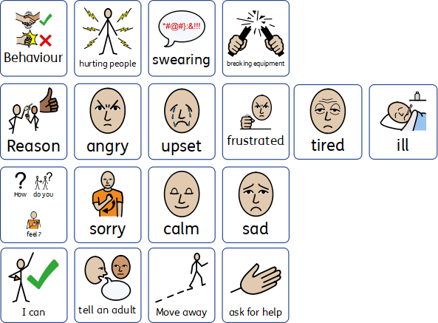

Appendix 7- Safe space guidance

Appendix 8- Safe Space recording sheet

